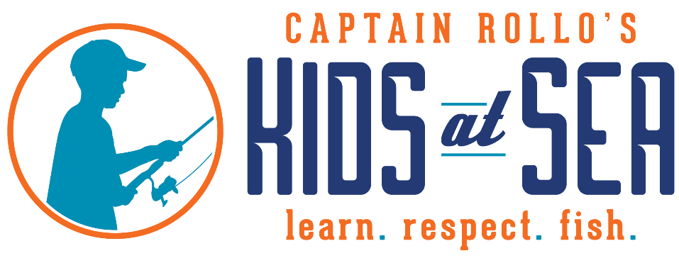

A child is an island of curiosity surrounded by a sea of question marks…
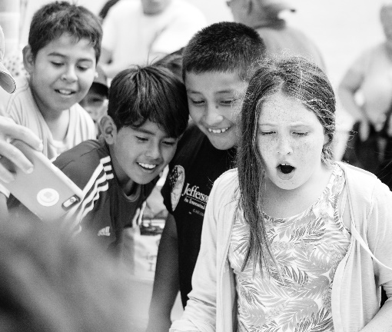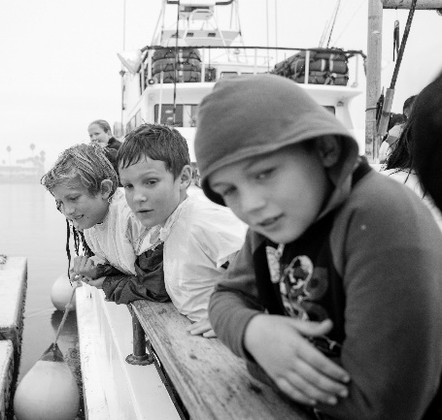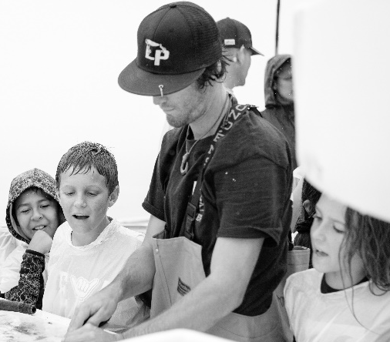

Captain Rollo’s Kids at Sea organizes marine- awareness fishing trips for children who might not otherwise have such an opportunity to witness the beauty and splendor of being on the ocean.
Youth are provided on-the-water ocean conservation education where they learn about the ecosystems in our coastal waters. We focus on serving disadvantaged, physically challenged, and at-risk youth. Since 1999, nearly 130,000 children have benefited.
Although many of the children served live locally and just a short distance from the ocean, often time, the Captain Rollo’s Kids at Sea fishing trip is their first ocean experience out on the water. From San Diego to Monterey Bay, we host half day fishing trips along our coastline.
Through Captain Rollo’s Kids at Sea, children will experience a day of beauty and nature while having the chance to experience something they might otherwise never witness- dolphins swimming in the bow’s wake, whales surfacing for air, sea lions playing around the boat are but a few of the lasting memories a day at sea will create.
Every child will remember their first boat ride and the first fish he or she caught. These experiences truly broaden a child’s horizons and instill a sense of awe and respect for the vast ocean and all of the creatures below. This one day often provides a life changing experience for the children fortunate enough to be a part of it.

Sponsorship Opportunities
Our priority is serving disadvantaged, physically challenged, and at-risk youth and will serve other groups of children based on available funding and co-sponsorship.
The generosity of our sponsors and donors allow us to provide these exclusive fishing excursions at no cost to the children and their families. Trips include a healthy snack, lunch, and beverages for the kids and their chaperones, rods, reels, Captain and crew on a Coast Guard approved vessel.
100% of your sponsorship funds trips for the kids! Multiple fundraising events held throughout the year cover administrative and operations costs. Encourage an organization YOU know to request a trip(s) and we can restrict your sponsorship funds to the requested group.

$2500 SEA LEVEL SPONSOR
Host 35 kids (1 trips) on a half day fishing excursion.
100% of your sponsorship funds trips.

$5000 ANCHORS AWEIGH SPONSOR
Host 70 kids (2 trips) on a half day fishing excursion.
100% of your sponsorship funds trips.
Company/Foundation logo displayed as $5000 ANCHORS AWEIGH SPONSOR on website.
Company/Foundation logo placed on banner as $5000 ANCHORS AWEIGH SPONSOR displayed at fundraising events.

$7500 STARBOARD SPONSOR
Host 105 kids (3 trips) on a half day fishing excursion.
100% of your sponsorship funds trips.
Company/Foundation logo displayed as $7500 STARBOARD SPONSOR on website.
Company/Foundation logo placed on banner as $7500 STARBOARD SPONSOR displayed at fundraising events.

$10,000 SHIP SHAPE SPONSOR
Host 140 kids (4 trips) on a half day fishing excursion.
100% of your sponsorship funds trips.
Company/Foundation logo displayed as $10,000 SHIP SHAPE SPONSOR on website.
Company/Foundation logo placed on banner as $10,000 SHIP SHAPE SPONSOR displayed at fundraising events.

$15,000 MAIDEN VOYAGE SPONSOR
Host 210 kids (6 trips) on a half day fishing excursion.
100% of your sponsorship funds trips.
Company/Foundation logo displayed as $15,000 MAIDEN VOYAGE SPONSOR on website.
Company/Foundation logo placed on banner as $15,000 MAIDEN VOYAGE SPONSOR displayed at fundraising events.

$20,000 ABOVE DECK SPONSOR
Host 280 kids (8 trips) on a half day fishing excursion.
100% of your sponsorship funds trips.
Company/Foundation logo displayed as $20,000 ABOVE DECK SPONSOR on website.
Company/Foundation logo placed on banner as $20,000 ABOVE DECK SPONSOR displayed at fundraising events.

$25,000 FROM STEM TO STERN SPONSOR
Host 350 kids (10 trips) on a half day fishing excursion.
100% of your sponsorship funds trips.
Company/Foundation representatives join fishing excursion with the kids.
Company/Foundation logo displayed as $25,000 FROM STEM TO STERN SPONSOR on website.
Company/Foundation logo placed on banner as $25,000 FROM STEM TO STERN SPONSOR displayed at fundraising events.

$50,000 LEADING LIGHT SPONSOR
Host 700 kids (20 trips) on a half day fishing excursion.
100% of your sponsorship funds trips.
Company/Foundation representatives join fishing excursion with the kids.
Company/Foundation logo displayed as $50,000 LEADING LIGHT SPONSOR on website.
Company/Foundation logo placed on banner as $50,000 LEADING LIGHT SPONSOR displayed at fundraising events.

$100,000 BIGWIG SPONSOR
Host 1400 kids (40 trips) on a half day fishing excursion.
100% of your sponsorship funds trips.
Company/Foundation representatives join fishing excursion with the kids.
*Private charter ¾ day fishing trip for 40 guests at landing location of choice.
*Costs are not deducted from donation amount.
Custom designed 6-foot $100,000 “Big Check” presentation with group photo and video opportunities at the dock with Company/Foundation representatives, kids, and crew; photos and videos provided for use on social media, website, publication, etc.
Company/Foundation logo displayed as $100,000 BIGWIG SPONSOR on website.
Company/Foundation logo prominently placed on banner as $100,000 BIGWIG SPONSOR displayed at fundraising events.
Company/Foundation logo on joint press release announcing $100,000 BIGWIG SPONSORSHIP including quote from executive.
Hosted invitation for Company/Foundation executive to attend annual “Tuna Wars” Celebrity Fundraiser & Auction.
Certificate of Recognition presented to Company/Foundation executive as a $100,000 BIGWIG SPONSOR and invitation for to speak at the event.

For Sponsorship Opportunities, please contact Harold Davis, Board President, at
davisboats@thegrid.net or 805-441-9576.

Captain Rollo’s Kids at Sea
2580 Ingraham Street
San Diego, CA 92109
858-350-5870 Phone / 858-350-5875 Fax
www.captainrollos.org
A 501(C) 3 Non-Profit Educational Organization
Tax ID 45-5624805
***Photos and videos may only be used pending signed authorization by parents/guardians of the kids.

